NewsLetter (150 points)
Create a Web page (HTML5 + CSS3 + images) that looks like the screenshot below:
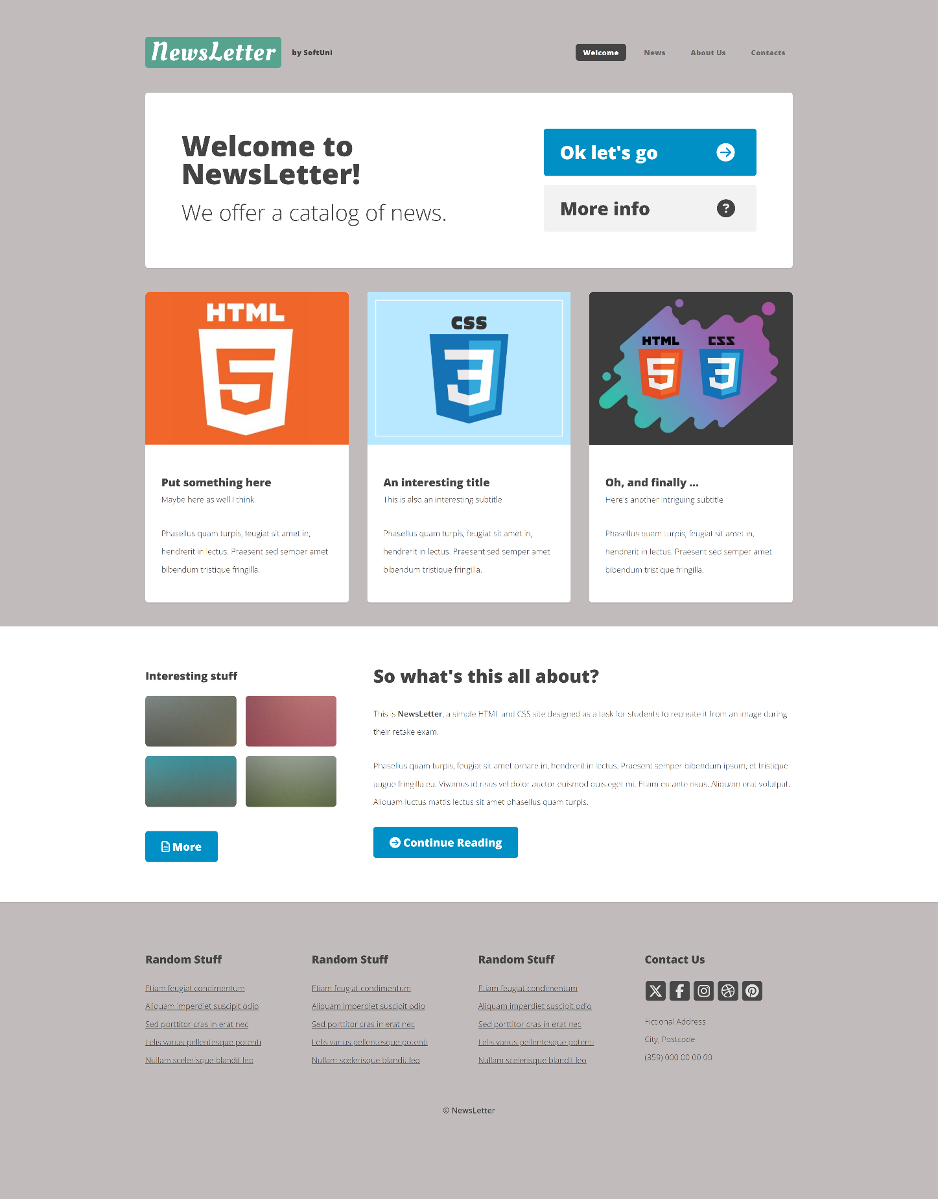

You are given the above screenshots + all required images.

Output
The output should be valid HTML5 + CSS3 + images that implement the above web page.

Constraints
- Use fonts 'Oleo Script', serif and 'Open Sans', sans-serif – they are already imported in CSS file.
- Hint: You will need 'Oleo Script' in the logo.
- The site should open correctly in the latest version of Chrome

IMPORTANT: Do not change the structure of the provided exam resources. You may create files, but do not create new folders, rename existing ones, or move them to other directories.

Hints:
- Background: Use a color picker tool to identify the background color of the image and apply it to the frontend design.
- Icons with Font Awesome: Use Font Awesome to include icons in your frontend design. For the "Contact Us" section, you will need icons for X (Twitter), Facebook, Instagram, Dribbble and Pinterest.

